MY SMALL BIO – ROSANE VIEGAS
Rosane Viegas holds a degree in Civil Engineering and currently works as a sculptor and printmaker. In the art, he was self taught and had as masters Pedro Fogaça - drawing, watercolors and living model (1994/1996) and Marco Rossi (1997/1999) painting on canvas. She began modeling in 2002 in the atelier of the sculptor Israel Kislansky and some of her works are awarded in the USA. In 2011 she learned metal engraving in the ECA Extension Course and fell in love. Researching, reading, studying and experimenting developed sustainable techniques in metal engraving such as electro gravure (technique unknown in Brazil), as well as developing techniques in conventional engraving as if making transparencies in etching.  She studies and develops monotypes and sustainable engravings on etching and other materials. She developed a colored monotype using as a matrix the packaging Tetra Pak, alone and along with other matrix as woodcut, etching etc. She currently manages Casa Tamarindo, an art Study and Residence Artistic in Sao Paulo – Brazil, where she develops her studies in engraving, sculptures and watercolor and teaches all these techniques. | 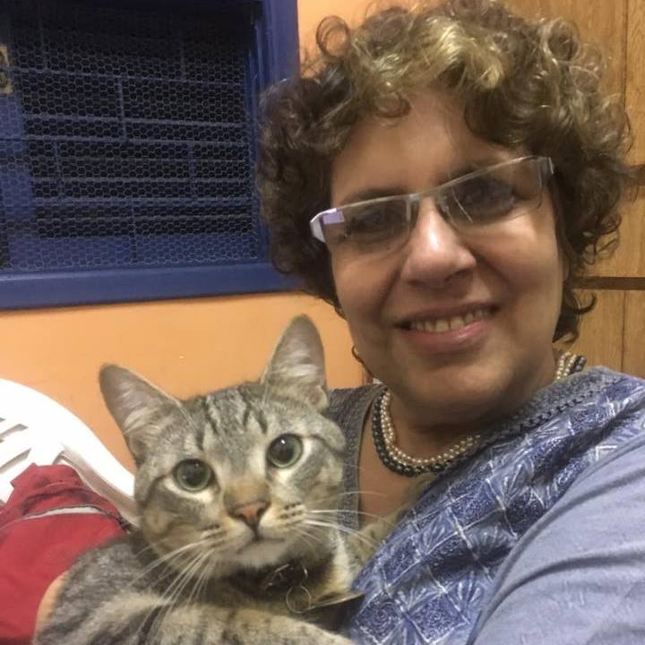
Rosane Viégas was born in Belo Horizonte and now lives in São Paulo. She is 61 years old. She usually takes part of art shows in Brazil and other countries, since 2000.

Contact: rosane.viegas@yahoo.com.br
Site: www.rosaneviegas.com

MAIN EXIBITIONS
2018 - REMEMBER-13/04 to 04/19/2018 - Art Studio Bazzini 15, via Bazzini 15, Milan - Italy.
2018 - Participate in the Exhibition AMARRANDO OS CADARÇOS – 06/04 to 30/04/2018 Shopping Center Taubaté - Taubaté - SP and OVO DE PÁSCOA Exhibition - 06/03 to 31/03/2018 Shopping Center Taubaté - Taubaté - SP.
2017 – November/2017 - accepted at the 4th International Small Etching Biennial Graphium -2017 Show - Timisoara - Romania.
2017 - 7/12/2017 - Honorable Mention on Divergent Ink: Black and White International Print Exhibition - October 13 - December 7, 2017 – USA
2017 – 28/09 until 03/10/2017 – Show Small Format 2017 – Dublin – Ireland.
2017 – 23/09/2017 until 26/02/2018 Commemorative Show of 30 YEARS OF XILOGRAPHY MUSEUM – CAMPOS DO JORDÃO – SP – Brazil.
2017 – 17/09/2017 – Accepted on the competition – Divergent Ink: Black & White – Akron – Ohio - USA
2017 - 12/08/2017 - Accepted on the competition – Small Forms 2017 - Black Church Print Studio – Dublin – Ireland.
2017 - 12-13/08/2017 - 6ª edition of Design Weekend - BIBLIAPSA –São Paulo – SP.
2017 -20/07/2017 – Accepted on the competition OPEN CALL FOR THEMED EXCHANGES PORTIFOLIO: HODOLOGY: LANDSCAPE IN MOTION – las Vegas 2018 – Alterated landscapes from the SGC INTERNATIONAL.
2017 - 07/03/2017 - 3 of her woodcuts are part of the permanent collection of the XYLOGRAPHY MUSEUM IN CAMPOS DO JORDÃO.
2017 - 26/06 to 30/07 - The Invisible the Visible of the Contemporary Millenarian - OAB - Jabaquara - Collective Exhibition of Engraving.
2017 - 02 to 30/06/2017 - Individual Show - Bodies at Taubaté Shopping Center – SP
2016 - He founded Tamarindo, Studies in Art and Culture where he teaches classes in calcogravura, woodcut, watercolor and sculpture. He conducts research on electrogravure, green engraving using tetra Pak packaging, Gelli Printing, and also studies innovative calcography techniques.
2015 - Collective Exhibition - In the Red -Shopping Center Continental - 02/07 To 07/30/2015
2014 - 7th. Exhibition of Prints for Peace - Monterrey, Mexico / Prints for Peace - São Paulo - Brazil.
2014 - Officina Workshop – and SP ESTAMPA - White Permeable Base Workshop / Viscosity Printing / Eletroetching
2012 - Individual Exhibition Check Mate - 4 to 10/31/2012
2012 - Map of Influences Project - São Paulo - SP, Rio de Janeiro - RJ, Recife - PE and Porto Alegre - RS.
2010 - 10th Exhibition of Engravings in the Parque da Água Branca
2010 / 2011-11th Fine Arts show - Plano Texas USA -04/12/2010 to 06/06/2011
2005 - X International Circuit of Brazilian Art - Recoleta Cultural Center - Buenos Aires - Argentina - 08/26 to 09/09/2005
2003 - Viridian Artists - Viridian Artists in Blue - 530 W. 25th St. 4th fl. Room 407 NY 10001 - New York - USA - 17-23/03/2003
2003 - Santander Banespa Cultural Space - Individual Exhibition - Way to Infinity - R. João Brícola, 32 - 17 to 28/11/2003
2003 - VIII International Circuit of Brazilian Art - Selected as representative of São Paulo in the Sculpture modality with the Madeleine Work. Exhibitions:
Canning House Gallery - Brazilian Paintings - 2 Belgrave Square, London SW1H8PJ - London - England - 12 - 18/05/2003
The Casa do Brasil - Exhibition of Brazilian Art - Av. Arco da Victoria, s / n 28040 - Madrid - Spain - 20 to 26/05/2003
The UCCLA in Lisbon - Brazilian Art Exhibition - 05/28 to 06/3 2003 - Rua de São Bento, 640 - Lisbon - Portugal
The Palais Palffy - Brasilian Paintings - Josefsplatz 6 A-1010 - Vienna - Austria - 06/06 to 10/06 of 2003
Palazzo Dora Pamphili - The Best of Contemporary Art - Piazza Navona, 14 a 18 - Rome - Italy - 3 a 14/11/2003
2002 - Viridian Artists - Viridian Artists in Chelsea - 530 W. 25th St. 4th fl. Room 407 NY 10001 - New York - USA 26/11 to 14/12/2002.

